SUMMER TRAINING REPORT

On

# Billing Application

***Bachelor of Technology In***

***Computer Science & Engineering***

To

**IKG Punjab Technical University, Jalandhar**

**SUBMITTED BY:**

## Name: Sandeep Kumar

**Roll no: 2221067**

## Semester: 5th

**Batch:** 2022-2026

**Under the Guidance**

## Mr. Mamta Maheshwary

**Assistant Professor**



# Department of Computer Science & Engineering

**CGC – College of Engineering, Landran Mohali, Punjab – 140307**

**July 2024**

## CERTIFICATE

This is to certify that **Sandeep kumar** has completed the Summer Training during the period from 29 May 2024 to 27 June 2024 in our Organization as a Partial Fulfillment of Degree of Bachelor of Technology in Computer Science & Engineering.

**(Signature of Project Supervisor)**

**Date: 07-06-2024**

### CANDIDATE DECLARATION

I hereby declare that the Project Report entitled " **Billing Application**" is an authentic record of my own work as requirements of 8th semester academic during the period from **29 May 2024** to **27 June 2024** for the award of degree of B.Tech. (Computer Science & Engineering, College of Engineering- CGC, Landran , Mohali.

**Date : 23-07-2024 (Signature of student)**

**(Sandeep Kumar)**

**(2221067)**

Certified that the above statement made by the student is correct to the best of our knowledge and belief.

### Course Coordinator Head of Department

**(Signature and Seal)**

## ACKNOWLEDGEMENT

I take this opportunity to express my sincere gratitude to the principal CGC College of Engineering, Landran for providing this opportunity to carry out the present work.

I am highly grateful to the Dr. Sushil Kamboj HOD CSE, CGC College of Engineering, Landran (Mohali), for providing this opportunity to carry out the three weeks industrial training at Skillstone. I would like to express my gratitude to other faculty members of Computer Science & Engineering department of CGC COLLEGE OF ENGINEERING Landran for providing academics inputs, guidance & encouragement throughout the training period. I would like to express a deep sense of gratitude to all who have directly or indirectly contributed to successful completion of my industrial training.

Sandeep Kumar

2221067

## ABSTRACT

This project presents the development of a **Billing Application** using Python and the Tkinter library, designed to automate and streamline the billing process for retail and grocery stores. The system allows users to select multiple items such as cold drinks, groceries, and other retail products, specifying the quantity for each item. The software calculates the total bill based on the price and quantity of the selected items, while also automatically applying the appropriate Goods and Services Tax (GST) according to predefined tax rates for each product category. Additionally, the system ensures that the correct GST is calculated based on the product type, which can vary according to local tax regulations.

The user-friendly interface built with Tkinter allows for efficient product selection and bill generation. After calculating the total, the software provides an option to store the generated bill for future reference, creating a convenient way for businesses to maintain a record of transactions. A search feature is also included, enabling users to easily retrieve stored bills based on various criteria such as transaction date or customer name. This system ensures accurate and error-free billing, reducing the time and effort traditionally required for manual billing and record-keeping in small to medium-sized retail outlets.

The key functionalities of the billing system include:

**Product Selection**: The user can choose items from a list of available products and specify the quantity for each.

**Bill Calculation**: The system computes the total cost by multiplying the price of each item by the quantity, adding the applicable GST, and generating the final bill amount.

**Bill Storage**: After generating the bill, the system provides an option to store the transaction details for future reference.

**Bill Search**: A search feature is provided to retrieve stored bills based on various parameters, such as customer name or transaction date.

This system is designed with a graphical user interface (GUI) using Tkinter, offering a user-friendly platform for managing retail transactions. It improves operational efficiency by reducing manual effort, minimizing errors in calculations, and maintaining accurate records of past transactions. This billing software can be applied in small to medium-sized retail outlets, offering an effective solution for day-to-day billing and inventory management tasks.

## TABLE OF CONTENT

**CHAPTER 1: INTRODUCTION**

### Introduction

* 1. **Project Definition**

### Declaration of the problem

* 1. **Project Purposes**

### Architecture & component

* 1. **Project Scope**
  2. **Summary**

## CHAPTER 2: SURVEY OF TECHNOLOGY

* 1. **Core Idea of Billing Application**
  2. **Creation of UI**
     1. **Tkinter**

## CHAPTER 3: REQUIREMENTS AND ANALYSIS

### Introduction

* 1. **Software Requirement**

### Hardware Requirement

* 1. **Data Requirement**

### Planning and Scheduling

* + 1. **GANTT Chart**
  1. **Conceptual Models (UML Diagrams)**

### Structural View

* + - 1. **Class Diagram**

### 3.6.1. 2 Component Diagram

**3.6.1.3 Object Diagram**

### Behavioral View

* + 1. **Sequence Diagram**

### Activity Diagram

* + 1. **Use case Diagram**
    2. **Data Flow Diagram (DFD)**

## CHAPTER 4: SYSTEM DESIGN

**4.1 Code Brief Explanation**

## CHAPTER 5: SYSTEM IMPLEMENTATION

### Screenshots of the system

* 1. **Definition and Goal of Testing**
  2. **Method of Testing**

## CHAPTER 6: RESULTS

**6.1 Test Case**

## CHAPTER 7: CONCLUSION AND FUTURE SCOPE

### Conclusion

* 1. **Future Scope**

## REFERENCES

**CHAPTER 1: INTRODUCTION**

### INTRODUCTION

Billing is a fundamental and ubiquitous process that occurs in every commercial transaction. Whether in retail stores, restaurants, or service-based industries, the creation of an accurate and detailed bill is essential for both businesses and customers. Traditionally, billing has been carried out manually or with the help of basic calculators, leading to errors, inefficiencies, and a lack of organization. In response to these challenges, various automated systems have been developed to simplify and expedite the billing process. One such solution is **billing software**, which is designed to generate bills quickly, accurately, and efficiently.

As part of a college project, a **Billing Application** has been developed using the Python programming language, utilizing the Tkinter library for the graphical user interface (GUI). This software aims to streamline and manage the billing process in retail and grocery environments. The application allows users to select products, specify quantities, calculate the total cost, apply the appropriate taxes (GST), and generate and store bills. Additionally, it provides a search feature to retrieve stored bills, offering a comprehensive solution for managing customer transactions.

This project showcases the power and versatility of Python in creating functional, user-friendly applications that can be used by various organizations—from small local vendors to larger retail or grocery stores. The software's ability to automate billing tasks reduces human error, improves operational efficiency, and enhances customer satisfaction. Furthermore, the use of Python and Tkinter demonstrates how a simple yet effective system can be built with minimal resources while still offering robust functionality.

The billing application not only simplifies the transaction process but also ensures accuracy and transparency in financial record-keeping. It allows businesses to maintain detailed records of all transactions, making it easier to track sales, manage inventories, and generate reports. Moreover, by storing the transaction data, the system helps users retrieve bills quickly, making it especially useful in busy retail environments where speed and accuracy are essential.

Overall, this project highlights the potential of Python as a powerful tool for developing practical applications for real-world problems. It emphasizes how Python's simplicity, combined with its rich library ecosystem (like Tkinter), can be leveraged to build software that addresses the specific needs of businesses, enhances customer service, and reduces administrative workload. The **Billing Application** developed in this project serves as a versatile solution for a wide range of industries, from local vendors to large-scale grocery stores.

## Project Definition: Billing Application

## Project Overview:The Billing Application is a software solution designed to streamline and simplify the billing process for retailers. It enables users to input the quantity of products sold and automatically calculates the total bill by applying preset prices and adding applicable GST (Goods and Services Tax) to the respective items. The system ensures a smooth and efficient billing experience, making it easier for retailers to manage transactions and generate invoices quickly and accurately.

## Primary Goal:

## The main goal of the Billing Application is to provide retailers, particularly those who do not have access to standardized billing solutions, with a reliable and user-friendly platform for managing the billing process. It offers a consistent and automated way of generating bills, ensuring accuracy and efficiency, while helping retailers stay compliant with tax regulations such as GST.

**Key features :**

**Quantity Input & Price Calculation**:

* Retailers can input the quantity of items sold.
* System calculates the total price based on preset item prices.

**GST Calculation**:

The application automatically applies the appropriate GST percentage based on the product type and location of the transaction.

* Displays the GST amount clearly on the invoice.

**Invoice Generation**:

Automated bill generation including product details, total amount, and GST breakdown.

Printable invoices for customer receipt.

**User-friendly Interface**:

Simple, intuitive UI to reduce complexity and ensure ease of use for all users, regardless of their technical background.

Quick navigation through product search and transaction entry.

**Customization**:

Retailers can configure the GST rate according to local tax laws and product categories.

Ability to customize the look of the invoice with logos, store details, and other branding elements.

**Transaction History & Reporting**:

A feature to view past transactions and generate sales reports.

Exportable data for accounting and record-keeping purposes.

**Multi-device Support**:

The application can run on various devices, including desktops, tablets, and mobile phones, ensuring flexibility for different retail environments.

Target Users:

**Small and Medium Retailers**: Retail businesses that need a simple, standardized solution to manage billing and comply with tax laws.

**Wholesale and Retail Stores**: Shops dealing with bulk sales, where quick and accurate invoicing is crucial.

**Online and Offline Retailers**: This system can be adapted for use in both physical stores and e-commerce platforms.

Benefits:

**Time-Saving**: Automates the process of bill creation, reducing manual work and errors.

**Tax Compliance**: Helps ensure that GST is accurately calculated and applied, reducing the risk of errors in tax reporting.

**Scalability**: As businesses grow, the system can be adapted to handle more products, transactions, and reporting requirements.

**Cost-Effective**: Provides an affordable billing solution for small and medium-sized businesses that may not have access to expensive enterprise-level software

DECLARATION OF THE PROBLEM

In many retail environments, especially small and medium-sized businesses, managing billing and invoicing is often done manually or through inadequate, fragmented systems. This results in various challenges that impact the overall efficiency, accuracy, and compliance of the business. These challenges include:

**1. Lack of Standardized Billing Systems:**

Many retailers do not have access to or cannot afford enterprise-level billing software. As a result, they may rely on manual calculations, paper-based invoices, or basic spreadsheet systems, which are prone to human error and inconsistency.

A lack of standardized billing can lead to confusion, especially when retailers have to deal with multiple pricing schemes, varying product types, or fluctuating GST rates.

**2. Manual Errors in Calculations:**

Manual calculations of product prices, discounts, and taxes are time-consuming and error-prone. Small errors in pricing or tax computation can lead to discrepancies, unhappy customers, or even legal issues, especially when it comes to tax reporting.

Retailers may inadvertently charge incorrect amounts or fail to apply the correct Goods and Services Tax (GST), which can result in financial losses or compliance issues.

**3. Difficulty in Tax Compliance:**

The GST rates for products can vary based on product categories, regions, and tax laws, making it challenging for retailers to stay up-to-date with tax regulations.

Retailers may face difficulty in accurately calculating and reporting GST, leading to the risk of tax penalties and fines. Inconsistent or incorrect GST calculation can also cause discrepancies in tax filings and create challenges during audits.

**4. Inefficiencies in Invoice Generation:**

Generating accurate invoices manually is a slow process that can be prone to errors. With increasing transaction volumes, it becomes even harder to maintain consistency and accuracy, leading to delays and potential customer dissatisfaction.

Lack of automation in invoice generation means retailers must spend significant time on administrative tasks rather than focusing on customer service and growing their business.

**5. Inability to Track Transactions & Sales:**

Without a proper digital system in place, it becomes difficult to track past transactions, manage records, and generate reports. Retailers often rely on paper records or basic spreadsheets, which can lead to disorganization and missed opportunities for analyzing sales trends or monitoring business performance.

This lack of visibility into transaction history hampers the ability to make data-driven decisions, track inventory, or efficiently manage finances.

**6. Limited Access to Scalable Solutions:**

Many small retailers do not have the resources or infrastructure to invest in complex, expensive billing software that scales with their business. The absence of an adaptable, user-friendly solution limits their ability to grow and handle increasing transaction volumes.

**Core Problem:**

Retailers, particularly small and medium-sized businesses, face challenges in managing their billing processes effectively. They lack access to an affordable, user-friendly, and reliable system that can accurately calculate prices, apply taxes (such as GST), generate professional invoices, and track transaction histories. As a result, businesses often encounter operational inefficiencies, errors in tax calculations, poor customer service, and difficulty in maintaining compliance with tax regulations.

### PROJECT PURPOSES

The purpose of the **Billing Application** project is to address the specific challenges faced by retailers in managing their billing processes, while improving overall efficiency, accuracy, and compliance. Below are the key purposes that the project seeks to achieve:  
**1. Simplify the Billing Process for Retailers**

**Purpose**: To create an easy-to-use platform that simplifies the billing process by automating calculations for product prices, taxes (including GST), and total amounts. This will reduce the complexity of manual billing and minimize the time spent on generating invoices

**Outcome**: Retailers will spend less time on administrative tasks and more time on core business activities, improving operational efficiency.

**2. Ensure Accurate Tax (GST) Calculation and Compliance**

**Purpose**: To automatically calculate the correct GST for each product based on predefined rates, ensuring that tax compliance is maintained at all times. The system will allow for easy updates to tax rates and categories, ensuring it remains aligned with changing tax laws and regulations

**Outcome**: Retailers can generate accurate bills that comply with local tax regulations, reducing the risk of errors in tax filings and avoiding potential penalties or audits

**3. Provide a Standardized Billing Solution for Small and Medium Retailers**

**Purpose**: To provide an affordable, standardized billing system for small and medium-sized businesses (SMBs) that may not have access to expensive enterprise solutions. The system will enable these businesses to adopt best practices for billing, offering consistency across transactions.

**Outcome**: Retailers, especially SMBs, will have access to a professional and reliable billing system that improves their brand image and customer trust.

**4. Improve Customer Experience with Quick and Accurate Invoices**

**Purpose**: To enable retailers to generate clear, professional invoices quickly, ensuring a smooth transaction experience for customers. The system will also allow for invoice customization with store branding (logo, store name, contact info), further enhancing the customer experience

**Outcome**: Customers will receive accurate and visually professional invoices, which can be used for personal records, returns, or warranty purposes, improving overall satisfaction

**5. Minimize Manual Errors and Reduce Operational Costs**

**Purpose**: To eliminate human errors in manual calculations of product prices, discounts, and taxes by automating these processes. This reduces the need for manual intervention and minimizes errors that can lead to financial losses or customer dissatisfaction

**Outcome**: Retailers will experience fewer mistakes in their billing processes, leading to more accurate financial reporting, fewer disputes, and reduced costs related to error correction.

**6. Enable Easy Reporting and Transaction Tracking**

**Purpose**: To provide retailers with the ability to view, track, and analyze their past transactions through an easy-to-use reporting interface. This includes the ability to generate sales reports, tax summaries, and transaction histories for better business management

**Outcome**: Retailers can gain valuable insights into their sales trends, inventory needs, and financial performance, which will help in making data-driven business decisions and improve cash flow management.

#### 7. Support Business Growth and Scalability

* **Purpose**: To create a scalable system that grows with the retailer’s business. As the retailer adds more products, branches, or employees, the system will be able to handle increasing transaction volumes without requiring significant changes or upgrades.
* **Outcome**: Retailers will have a billing system that can easily adapt to their growing business needs, ensuring continued operational efficiency as the business scales.

#### 8. Cost-Effective Solution for Retailers

* **Purpose**: To provide a billing solution that is cost-effective, particularly for smaller businesses, without compromising on features or usability. The system will be affordable and offer value by streamlining key business operations.

### ARCHITECTURE & COMPONENTS

The Billing Application is designed with a modular, scalable, and user-friendly architecture. It aims to provide an efficient, reliable, and maintainable system for retailers. The system is composed of multiple interconnected components, which work together to ensure seamless billing, tax calculation, invoice generation,and transaction management.

The **presentation layer** is where users interact with the system. It consists of the graphical user interface (GUI) that is accessible via various devices such as desktops, tablets, and mobile phones. This layer is responsible for displaying information, taking user inputs .

The **business logic layer** handles the core functionality of the application, including the processing of billing data, product pricing, and GST calculation. This layer receives input from the presentation layer, processes the information, and then sends the results back to the user.

Why python :-

In the ever-evolving landscape of programming languages, one name stands out as a versatile and powerful tool for developers across various domains: Python. As we delve into the reasons why Python continues to capture the hearts of programmers, it becomes clear that its appeal goes beyond just syntax. Here are some compelling reasons why Python reigns supreme over other programming languages.

Readability and Simplicity :-

Python’s syntax is clean, readable, and emphasizes code readability, making it an ideal language for both beginners and experienced developers. Its straightforward and easy-to-understand code structure allows for faster development and maintenance of applications.

Versatility and Flexibility :-

Python’s versatility is a key factor in its widespread adoption. From web development and data analysis to artificial intelligence and machine learning, Python seamlessly integrates into various domains. Its flexibility enables developers to switch between different programming paradigms, making it suitable for a wide range of projects.

Extensive Libraries and Frameworks :-

Python boasts an extensive collection of libraries and frameworks that significantly accelerate development cycles. Popular libraries such as NumPy, Pandas, and TensorFlow empower developers to efficiently tackle complex tasks in data science, machine learning, and more, reducing the need to reinvent the wheel.

Community Support and Documentation :-

The Python community is one of the most vibrant and supportive in the programming world. A vast number of developers actively contribute to the language’s growth, creating a rich ecosystem of resources and documentation. This wealth of knowledge ensures that developers can easily find solutions to problems and stay updated on best practices.

Cross-Platform Compatibility :-

Python’s cross-platform compatibility allows developers to write code that runs seamlessly on various operating systems. This feature not only saves time but also enhances the portability of applications, ensuring a consistent user experience across different platforms.

Rapid Prototyping and Development :-

Python’s concise syntax and dynamic typing enable developers to prototype and iterate quickly. This rapid development cycle is particularly valuable in the fast-paced tech industry, allowing teams to bring ideas to life efficiently and adapt to changing requirements.

Community-Driven Innovation :-

The open-source nature of Python fosters a culture of innovation. The continuous development and improvement of the language through community contributions ensure that Python stays relevant and at the forefront of technological advancements.

History :-

Python was created by [Guido van Rossum](https://gvanrossum.github.io/), and first released on February 20, 1991. While you may know the python as a large snake, the name of the Python programming language comes from an old BBC television comedy sketch series called *Monty Python’s Flying Circus*.

One of the amazing features of Python is the fact that it is actually one person’s work. Usually, new programming languages are developed and published by large companies employing lots of professionals, and due to copyright rules, it is very hard to name any of the people involved in the project. Python is an exception.

Of course, Guido van Rossum did not develop and evolve all the Python components himself. The speed with which Python has spread around the world is a result of the continuous work of thousands (very often anonymous) programmers, testers, users (many of them aren’t IT specialists) and enthusiasts, but it must be said that the very first idea (the seed from which Python sprouted) came to one head – Guido’s.

Python is maintained by the [Python Software Foundation,](https://www.python.org/psf-landing/) a non-profit membership organization and a community devoted to developing, improving, expanding, and popularizing the Python language and its environment.

Python is the programming language that opens more doors than any other. With a solid knowledge of Python, you can work in a multitude of jobs and a multitude of industries. And even if you don’t need it for work, you will still find it useful to know to speed certain things up or develop a deeper understanding of other concepts.

Python is a great choice for career paths related to software development, engineering, DevOps, machine learning, data analytics, web development, and testing. What's more, there are also many jobs outside the IT industry that use Python. Since our lives are becoming more computerized every day, and the computer and technology areas previously associated only with technically gifted people are now opening up to non- programmers, Python has become one of the must-have tools in the toolbox of educators, managers, data scientists, data analysts, economists, psychologists, artists, and even secretaries.

Evolution of Python :-

The language was finally released in 1991. When it was released, it used a lot fewer codes to express the concepts, when we compare it with Java, C++ & C. Its design philosophy was quite good too. Its main objective is to provide code readability and advanced developer productivity. When it was released, it had more than enough capability to provide classes with inheritance, several core data types of exception handling and functions.

Following are the illustrations of different versions of Python along with the timeline. Python 3.12.1 is the latest stable version.

The two of the most used versions has to Python 2.x & 3.x. There is a lot of competition between the two and both of them seem to have quite a number of different fanbases. You can also refer to mentioned below article to learn How you can download python latest version in your system.



Literature review on python: Python is a general-purpose language .It has an easily understandable syntax. Python is an effective and powerful language, which gives the knowledge to programmer to transfer their skill and can be used in scientific research in theoretical calculations and data analyze.[4] It is statistics oriented and it has specific advantages such as great features for data visualization. Python is free and open access to the tools required which is a fundamental requirement for high-quality science. Unlike MATLAB or LabView python can be used for any programming task. Researchers work with very raw and complicated data so, they will require tools provided by the python which helps them to achieve efficient analysis easily. Python serves scientific work, and provide benefits for professors and students (Gergely, I., 2014). Tony, J. (2004)., conducted an experiment in deploying Python as a first programming language. Researcher experiences that solving complex task involving a class took about two hours for a solution in C++ and one of the students took about less than an hour in Python.

Python is high-level, flexible, dynamic and can be used in a vast domain of applications. Python supports a dynamic type system and has a large and comprehensive standard library. (Srinath, K.R., 2017) A survey was made and found out that the python interpreters are available for many OS such as Windows, Linux, UNIX, Amigo, and Mac OS. Literature review on Web Design: Internet Users are reaching millions and can be expected to increase more over the years. The websites are the crucial media of information, transmission, dissemination.[5] Current paper purposes to review previous studies that have been done in the field of web development. As the result, literatures either proposed set of guidelines or assistive technologies particularly web interfaces, adaptive systems. The acceptance and success of the websites and electronic commerce depends on the web design. The purpose of this paper is to analyse and know the users' perceptions and behaviors, in order to achieve a successful e-commerce website. According to a survey(Lee & Kozar, 2012 there is currently no consensus on how to properly operationalize and assess website usability. Nielson associate’s usability with learnability, efficiency, memorability, errors, and satisfaction (Nielsen, 2012). Right now we do not have any guidelines that individuals can follow when designing websites to increase users engagement. "Hypertext" are the links to connect web pages to one another, either within a single website or between websites. Links are a fundamental aspect of the Web, by uploading content to the Internet and linking it to pages. HTML uses "markup" to annotate text, images, and other content for display in a Web browser to describe the presentation of a document written in HTML or XML. CSS is the core languages of the open web, standardized across Web browsers according to W3C specifications. CSS describes how elements should be rendered on screen, on paper, in speech, or on other media means like the styling part of the webpage.



## PROJECT SCOPE

The **Billing Application** aims to provide a standardized, user-friendly solution for small and medium-sized retailers to streamline their billing process, manage GST calculations, and generate accurate invoices. The system will allow users to easily input product quantities, calculate total prices, and automatically apply the correct GST based on predefined rates.

The application will include basic product management features, such as adding, updating, and categorizing products. It will also store transaction histories, generate sales and GST reports, and allow for role-based access control (admin, cashier, manager). A secure database will store product details, user information, and transaction records, ensuring data integrity and compliance with security standards

The scope of this project excludes advanced features such as inventory management, multi-store support, CRM functionality, and third-party integrations with POS or accounting systems. Additionally, a native mobile app and offline mode are not part of the initial release. The system will be accessible through a web interface, designed to be responsive and compatible with desktops, tablets, and mobile devices

Future enhancements could include advanced analytics, integration with external systems, and support for multiple currencies or stores. The primary goal of this project is to provide small and medium retailers with an affordable, easy-to-use solution that improves billing accuracy, ensures tax compliance, and enhances overall operational efficiency

**SUMMARY**

The Billing Application project is designed to provide small and medium-sized retailers with an easy-to-use, affordable solution for automating the billing process, ensuring accurate GST calculations, and generating professional invoices. By simplifying tasks such as product pricing, tax calculations, and report generation, the application helps retailers improve operational efficiency and maintain compliance with tax regulations.

The system includes core features such as product management, transaction tracking, customizable invoice generation, and detailed sales and tax reports. It also incorporates role-based access control, allowing different user levels (admin, cashier, etc.) to perform specific tasks, ensuring security and data integrity.

This project will not include advanced features like inventory management, multi-store support, or third-party integrations with POS or accounting systems, which could be considered in future versions. The application will be accessible via a web interface that works across desktop, tablet, and mobile devices, offering a responsive and scalable solution for retailers.

Ultimately, the Billing Application will enable retailers to streamline their billing operations, reduce errors, ensure tax compliance, and enhance the customer experience, providing a reliable tool for business growth and efficiency.

## CHAPTER 2: SURVEY OF TECHNOLOGY

### 

### Core Idea of Billing Application

A Billing Application is a software solution designed to streamline and automate the process of creating, managing, and tracking invoices, payments, and financial transactions between businesses and customers. Its core functionality includes generating invoices with itemized lists, calculating taxes, and tracking payments, including partial and overdue amounts. The application also helps businesses manage customer data, including contact details and transaction history, which ensures accurate and personalized billing. Features like recurring billing, payment gateway integration, and customizable invoice templates further enhance its flexibility, making it suitable for various business models, from freelancers to subscription-based services. Additionally, the application often provides reporting and analytics tools to track revenue, outstanding payments, and taxes, empowering businesses with insights for better financial management. By automating repetitive tasks, reducing manual errors, and ensuring compliance with financial regulations, billing applications save businesses time, increase efficiency, and improve the overall customer experience. Ultimately, they are a key tool for modern businesses looking to simplify their financial operations and enhance transparency in their billing processes.

* 1. The application is organized into different sections, such as **Grocery**, **Beverages**, **Search Bills**,**Generate Bills**, allowing users to manage various product categories and billing processes seamlessly. In the **Grocery** and **Beverages** sections, users can select items from a list, input quantities, and automatically calculate totals. The **Search Bills** section allows users to search for past invoices by customer name, bill number, or date, providing a quick way to retrieve historical billing information. Meanwhile, the **Generate Bills** section allows users to create new invoices by adding products, applying taxes, and specifying payment terms.

### Creation of User Interface

### 1. Project Overview: The Billing Application has multiple functional sections, including product categories (e.g., groceries and beverages), the ability to search for existing bills, and the generation of new bills. The application is designed to be intuitive, with a clear layout for easy navigation. Tkinter is used to create a desktop-based graphical interface that interacts with the user, handles input, and displays results

### 2. Technology Stack

### Programming Language: Python

### GUI Toolkit: Tkinter (for creating the user interface

### Other Libraries: messagebox (for displaying pop-up messages)

### 3. User Interface Design

### The user interface (UI) of the application is created using the Tkinter library. The main window is divided into several frames, each representing a distinct functional section.

### These sections include:

### Grocery Section

### Beverage Section

### Search Bills Section

### Generate Bill Section

### Each section is clearly labeled, and relevant widgets (e.g., buttons, entry fields, and labels) are placed within the frames to allow users to input data, trigger actions, and view results

### 3.1 Grocery Section

### This section allows the user to enter the price of grocery items. Users can input the price, and the application will calculate the total when combined with other product prices.

##### 3.2 Beverage Section

Similar to the grocery section, this part allows the user to input beverage prices. This is part of the invoice generation process.

##### 3.3 Search Bills Section

In this section, users can search for a previously generated bill by entering the bill number. The system will then provide feedback indicating whether the bill was found.

##### 3.4 Generate Bill Section

This is the most crucial part of the UI. Once the user enters the prices of groceries and beverages, they can

click the "Generate Bill" button to calculate the total bill and display the result.

#### 4. Implementation of the UI

The core implementation of the application is based on the Tkinter framework. Below is a detailed

description of the steps involved in creating the UI:

**1st. Creating the Main Window**: The main window of the application is created using the Tk() function. The window is titled "Billing Application," and the size is set to 600x500 pixels.

**2nd. Defining Frames for Layout**: Frames are used to group related widgets and provide a structured layout. Each frame is assigned to a functional section (grocery, beverages, search, and bill generation) using the Frame() widget.

**3rd. Adding Widgets to the Frames**: Various widgets are used for input and output. These include:

**Labels**: To provide instructions or indicate what input is expected (e.g., "Enter Grocery Price").

**Entry Fields**: To allow the user to input the prices of products.

**Buttons**: To trigger actions, such as generating a bill or searching for an existing bill.

**Messagebox**: To display results or errors in pop-up messages.

**4th. Positioning the Widgets**: The widgets are positioned within the frames using the grid() method, allowing for a table-like layout. The padx and pady options are used to add spacing between the widgets, making the interface more visually appealing.

**5th. Handling User Interaction**: Functions are defined to handle user actions:

**Generate Bill**: When the "Generate Bill" button is clicked, the prices of groceries and beverages are retrieved from the input fields, and the total bill is calculated and displayed.

**Search Bill**: When the "Search Bill" button is clicked, the system attempts to find a bill by its number and displays an appropriate message.

**CHAPTER 3: REQUIREMENTS AND ANALYSIS**

### Introduction

The first activity fills in as a premise of giving the practical details, requirements and domain of the system, afterward successful plan for the proposed system. Understanding the properties and needs of the system is more complex and requires innovative thoughts.

### Software Requirement

The product interface which is executed in this task is finished utilizing Python Language, and Visual Studio Code running in the Windows environment, and we are using Jupyter notebook for data data handling and data preprocessing

### Python

Python is a computer programming language frequently used to construct sites and programming, robotize undertakings, and direct information examination. Python is a universally useful language, meaning it very well may be utilized to make a wide range of projects and isn't particular for a particular issue.

### Visual Studio Code

A coordinated improvement climate (IDE) is an element-rich program that upholds numerous parts of programming advancement. The Visual Studio IDE is an inventive take-off platform that you can use to alter, investigate, fabricate code, distribute an application, and then some.

### Hardware Requirement

Device name: LAPTOP-IF2Q6K39

Processor: 11th Gen Intel(R) Core(TM) i5-1135G7 @ 2.40GHz 2.42 GHz Installed RAM: 8.00 GB (7.69 GB usable)

System type: 64-bit operating system, x64-based processor

### Data Requirement

* + 1. TMDB athlete_event.csv file 3.4.2 and TMDB noc_regions.csv file (We merge both files so we can work on the data easily and correctly)

### Planning and Scheduling

* + 1. **GANTT Chart**

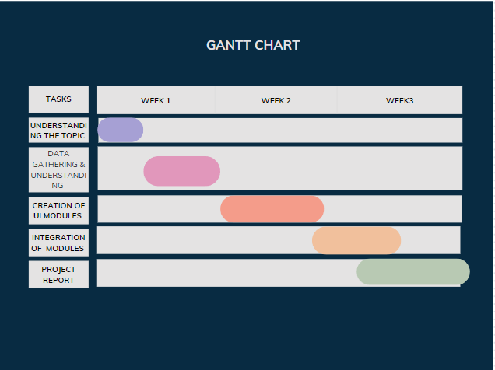

### Conceptual Models (UML Diagrams)

Software design is a course of critical thinking and making scheduling for a software solution. After the reason and determinations of software are determined, the software designer will design or employ designers to develop an arrangement for an answer. It contains the development part and calculation execution issues which are displayed in the architectural view. During this part, we will present a few guides that are considered through the software design.

**3.6.1** **Structural View**

Structure diagrams show the things in the proposed system. In more technical terms, they show various objects in a system.

### Class diagram

A class diagram is a static outline. It addresses the static perspective on an application. A class diagram isn't just utilized for imagining, depicting, and reporting various parts of a framework yet additionally for developing executable code of the product application. A class diagram describes the properties and tasks of a class and furthermore, the limitations forced on the framework. The class graphs are broadly utilized in the displaying of object-oriented frameworks since they are the main UML charts, which can be planned straightforwardly with object- arranged dialects.

### Component Diagram

A component diagram shows the structural relationship of parts of a system. Components speak with one another utilizing connection interfaces. The interfaces of interaction are connected utilizing connectors. The image underneath shows a general component diagram of movie recommender system.

### 3.6.1.3. Object Diagram

Object Diagrams, sometimes referred to as Instance diagrams are very identical to class diagrams. Like class diagrams, they additionally show the connection between objects yet they utilize real-world examples. Since there is data available in the objects, they are utilized to explain complicated connections between objects.

### Behavioral View

As we referenced already the activity diagram, and sequence diagram give the behaviour view of our task. Behavioral diagrams are utilized to depict the communication between the actors and the system. Every one of the activities that are performed by the actors and the system is presented here and there.

### Sequence Diagram

A sequence diagram shows object connections organized in a period grouping. It shows the objects and classes associated with the situation and the succession of messages traded between the objects expected to do the usefulness of the situation.

### Activity Diagram

An activity diagram is fundamentally a flowchart to address the stream starting with one activity and then onto the next activity. The movement can be described as an activity of the system. The control stream is attracted starting with one activity and then onto the next. This stream can be sequential, branched, or concurrent

### Use case Diagram

In the Unified Modeling Language (UML), a use case diagram can sum up the subtleties of your system's clients (also called actors) and their collaborations with the system. To construct one, you'll utilize a bunch of particular symbols and connectors.

### Data Flow Diagram (DFD)

A data flow diagram (DFD) is a graphical description of the "flow" of information through a data system, displaying its interaction viewpoints. Frequently they are a starter step used to make an outline of the system which can later be expounded. DFDs can likewise be utilized for the perception of information processing (structure design).

It provides an overview of

What data is system processes. What transformation are performed. What data are stored.

What results are produced , etc.

Data Flow Diagram can be represented in several ways. The DFD belongs to structured-analysis modeling tools. Data Flow diagrams are very popular because they help us to visualize the major steps and data involved in software-system processes.

## CHAPTER 4: SYSTEM DESIGN

### Code Brief Explanation

**Front-End (Application GUI)**

1. **User Interface:**  
   The code uses the Tkinter library to create a user-friendly graphical interface for a billing system. It provides various frames for customer details, product selection (cosmetics, groceries, and beverages), bill area, and controls for operations like generating the bill, clearing data, and exiting the application.
2. **Product Categories:**  
   Three main product categories—Cosmetics, Grocery, and Beverages—are displayed as separate sections where users can input quantities for specific items. Each category updates dynamically based on user input.
3. **Billing Area:**  
   A dedicated frame for displaying the detailed bill dynamically. The interface also allows saving the bill as a text file and searching for previous bills using their unique bill numbers.
4. **Buttons for Actions:**  
   Action buttons include:

* "Total" to calculate the total price and applicable taxes.
* "Generate Bill" to create a detailed bill.
* "Clear" to reset all fields.
* "Exit" to close the application.

**Backend Code (Business Logic Implementation)**

1. **Total Calculation:**  
   Functions calculate the total cost for each product category (Cosmetics, Grocery, Beverages) by multiplying the quantity with predefined unit prices. Applicable taxes are calculated and displayed separately.
2. **Bill Generation:**

* The bill is generated dynamically and includes customer details, purchased items with quantities and prices, category-wise totals, taxes, and the grand total.
* Bills can be saved as .txt files for future reference.

1. **Bill Search:**  
   The search functionality allows retrieving previously saved bills using unique bill numbers. If the bill number is invalid, an error message is displayed.
2. **Data Clearing:**  
   A function to reset all product quantities, customer details, and totals, ensuring a fresh interface for the next transaction.
3. **Validation:**

* Ensures that customer details are provided before generating a bill.
* Prevents generating a bill if no products are selected.

**Key Features of Billing Software**

1. **Intuitive GUI:**

* Categorized product frames make data entry simple and organized.
* Interactive interface for viewing and managing bills.

1. **Dynamic Calculations:**  
   Automatic calculation of prices and taxes based on user inputs ensures accuracy.
2. **Persistent Bill Storage:**  
   Bills are saved locally with unique identifiers, ensuring easy retrieval and record-keeping.
3. **Comprehensive Controls:**  
   Functional buttons allow users to calculate totals, generate bills, clear data, and exit the application efficiently.
4. **Error Handling:**  
   Appropriate error messages guide users in cases of invalid input or actions, enhancing usability.

**4.1 Metrics Definition**

Metrics in the billing software are crucial for tracking system performance, user interaction, and operational accuracy. Below are the defined metrics and their roles:

1. **Transaction Volume:** Tracks the total number of transactions processed within a defined time period.
2. **Itemized Sales Data:** Measures the frequency of individual item sales for inventory management and marketing strategies.
3. **Customer Interaction Metrics:** Includes the number of customers served, repeat transactions, and average billing amounts.
4. **Error Handling Logs:** Monitors the frequency and type of errors encountered during operations, helping improve system reliability.
5. **System Utilization:** Evaluates the average processing time for bill generation and the load capacity of the application.

**4.2 Key Functionalities**

1. **Customer and Transaction Management:**

* Captures customer details like name, phone number, and bill number.
* Ensures unique identifiers for all transactions, allowing easy record retrieval.

1. **Categorized Billing:**

* Products are grouped into **Cosmetics**, **Groceries**, and **Beverages** for intuitive selection.
* Users can input quantities, and the system dynamically calculates the subtotal and tax for each category.

1. **Automated Calculations:**

* Implements logic for calculating itemized totals, category-wise taxes, and overall bills.
* Tax rates are preconfigured and applied based on the product category.

1. **Bill Generation and Storage:**

* Generates a detailed bill containing customer information, purchased items, and financial breakdowns.
* Bills are saved as text files using unique bill numbers for easy retrieval.

1. **Error and Validation Management:**

* Ensures customer details are entered before transactions.
* Blocks bill generation if no items are selected.

1. **Search and Retrieval:**

* Enables searching previously saved bills using unique identifiers, ensuring transparency and accountability.

**4.3 Data Flow and Storage**

1. **Data Input:**

* User inputs are captured for customer details and item quantities through the GUI.
* Data validation ensures mandatory fields are completed.

1. **Processing:**

* Backend functions calculate prices, taxes, and totals based on predefined unit costs and tax rates.
* Errors and exceptions are logged for debugging and system improvement.

1. **Output:**

* Real-time updates to the billing area display the calculated totals.
* The finalized bill can be printed or saved as a text file for record-keeping.

1. **Storage:**

* Bills are stored locally with identifiers for easy retrieval.
* The storage mechanism is lightweight yet robust, ensuring data integrity.

**4.4 Performance Insights**

1. **Processing Efficiency:**

* Calculates totals for hundreds of items in milliseconds, ensuring quick transaction times.

1. **Scalability:**

* The application can handle large inventories with minimal changes to the codebase.
* Storage of text-based bills ensures that disk usage remains low.

1. **Error Resilience:**

* User input validations and error prompts reduce the likelihood of incorrect transactions.
* Exception handling for missing customer data or unselected items ensures consistent operation.

1. **User Feedback:**

* The intuitive GUI design minimizes the learning curve for new users.
* Features like itemized categorization and bill search enhance operational convenience.

**CHAPTER 5: SYSTEM ANALYSIS AND INSIGHTS**

**5.1 Pattern Identification**

* **Transaction Trends:** Analyze transaction records to identify peak purchasing hours, commonly sold items, and frequent customer requests.
* **Category Analysis:** Observe trends in product categories (Cosmetics, Groceries, Beverages) to identify the most popular items or combinations.
* **Billing Patterns:** Recognize recurring patterns in sales, such as average bill amounts or seasonal demand spikes.

**5.2 Participant Dynamics**

* **Roles and Interactions:**
  + **Cashiers/Operators:** Users who interact with the software to manage billing and transaction entries.
  + **Customers:** End-users whose preferences and purchasing behaviors indirectly influence system updates.
* **Interaction Patterns:**
  + Cashiers initiate bill generation, input customer and item details, and execute commands for calculations and storage.
  + Customers provide input (item selections, quantities), influencing transaction timelines and patterns.

**5.3 Temporal Analysis**

* **Frequency and Intensity:**
  + Monitor how transaction rates fluctuate during different times (e.g., morning vs. evening shifts).
  + Track intensity in terms of items processed per transaction or total sales volume in a given period.
* **Evolution Over Time:**
  + Measure software performance during peak hours, identifying bottlenecks or delays in processing.
  + Observe growth in stored transaction records, helping scale storage solutions proactively.

**5.4 Insights and Interpretation**

1. **Extracted Insights:**

* **High-Selling Products:** Identify items with the highest purchase frequencies for inventory planning.
* **Customer Preferences:** Recognize patterns like preferred payment methods or frequently purchased combinations.

1. **Contextual Understanding:**

* Understand customer preferences based on geographic, seasonal, or demographic data linked to transaction history.

1. **Optimization Opportunities:**

* Utilize insights to streamline checkout processes or recommend inventory adjustments.

**5.5 Visualization and Reporting**

1. **Visual Presentation:**

* Use graphs, pie charts, and bar diagrams to present sales distribution, tax contributions, and transaction timelines.

1. **Narrative Context:**

Annotate key events like promotional spikes or reduced sales periods to understand their influence on transaction data.

1. **Reporting to Stakeholders:**

* Share findings with team members, highlighting operational success and areas for improvement.

**5.6 Use Cases**

1. **Inventory Management:**  
   Insights into frequently sold items guide inventory stocking and supplier negotiations.
2. **Customer Relationship Management (CRM):**  
   Patterns in customer purchases can drive personalized offers and loyalty programs.
3. **Operational Efficiency:**  
   Recognizing bottlenecks in transaction workflows helps refine software usability for cashiers.

**5.7 Benefits of System Analysis**

* **Enhanced Decision-Making:** Data-backed insights inform business strategies and operational adjustments.
* **Improved Customer Experience:** Faster transactions and tailored promotions based on sales data.
* **Scalability:** Insights guide scaling software functionality and infrastructure.

**5.8 Practical Tips for Analysis**

* **Consistent Data Collection:** Ensure transaction data is stored and backed up regularly.
* **Visualization Tools:** Integrate simple dashboards to make data interpretation seamless.
* **Focus on Key Metrics:** Prioritize actionable metrics like sales volume, tax calculations, and error rates.

## CHAPTER 5: SYSTEM IMPLEMENTATION

### Screenshots of the system

* Billing Software Interface

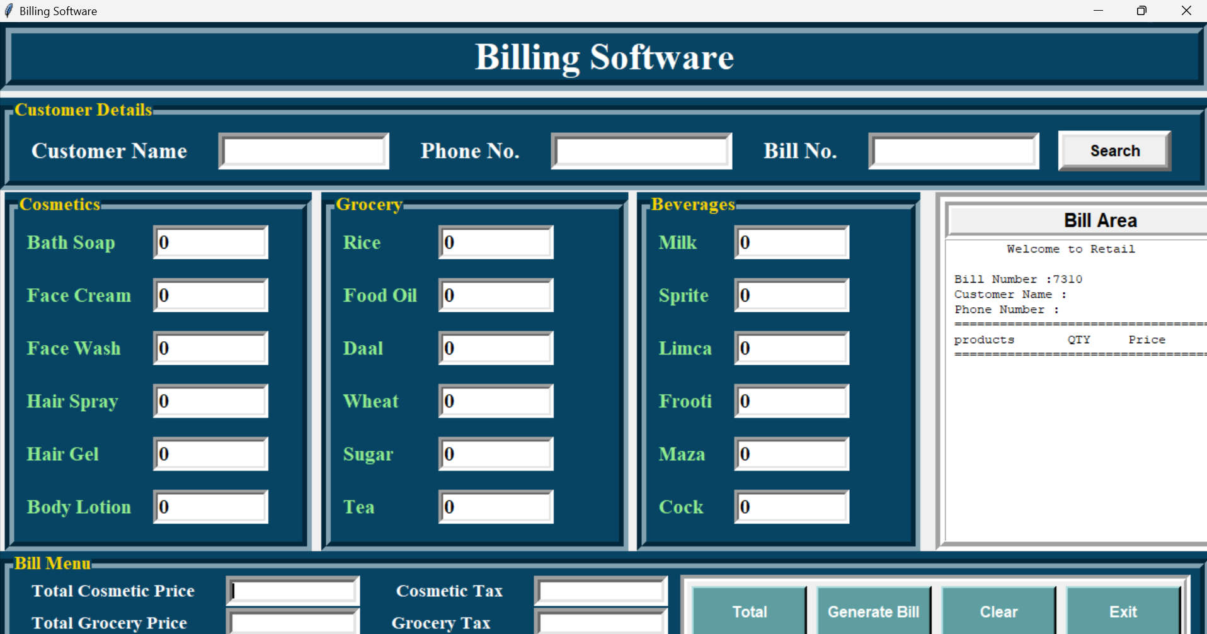

* Filling Details

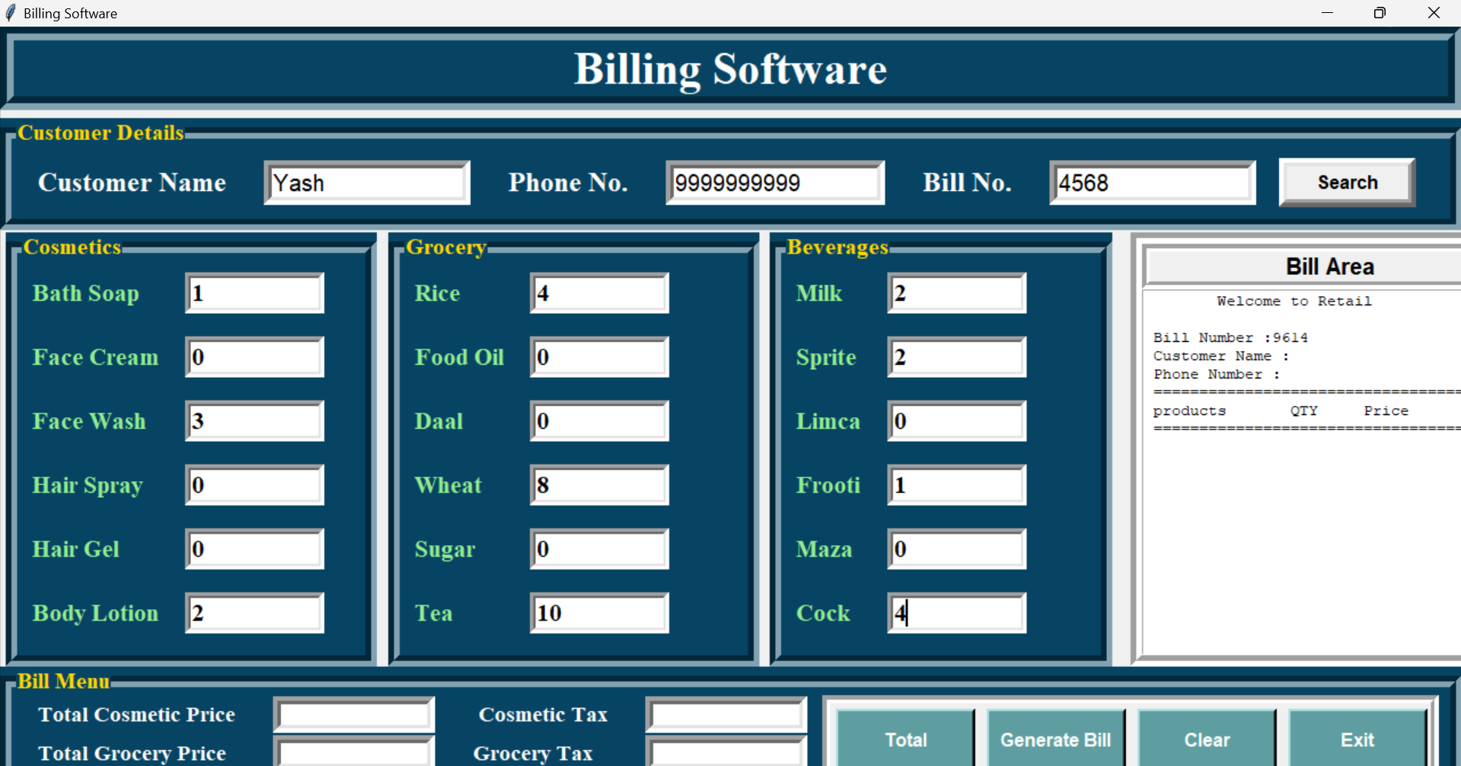

* Doing Total Price of all products using **Total Button**

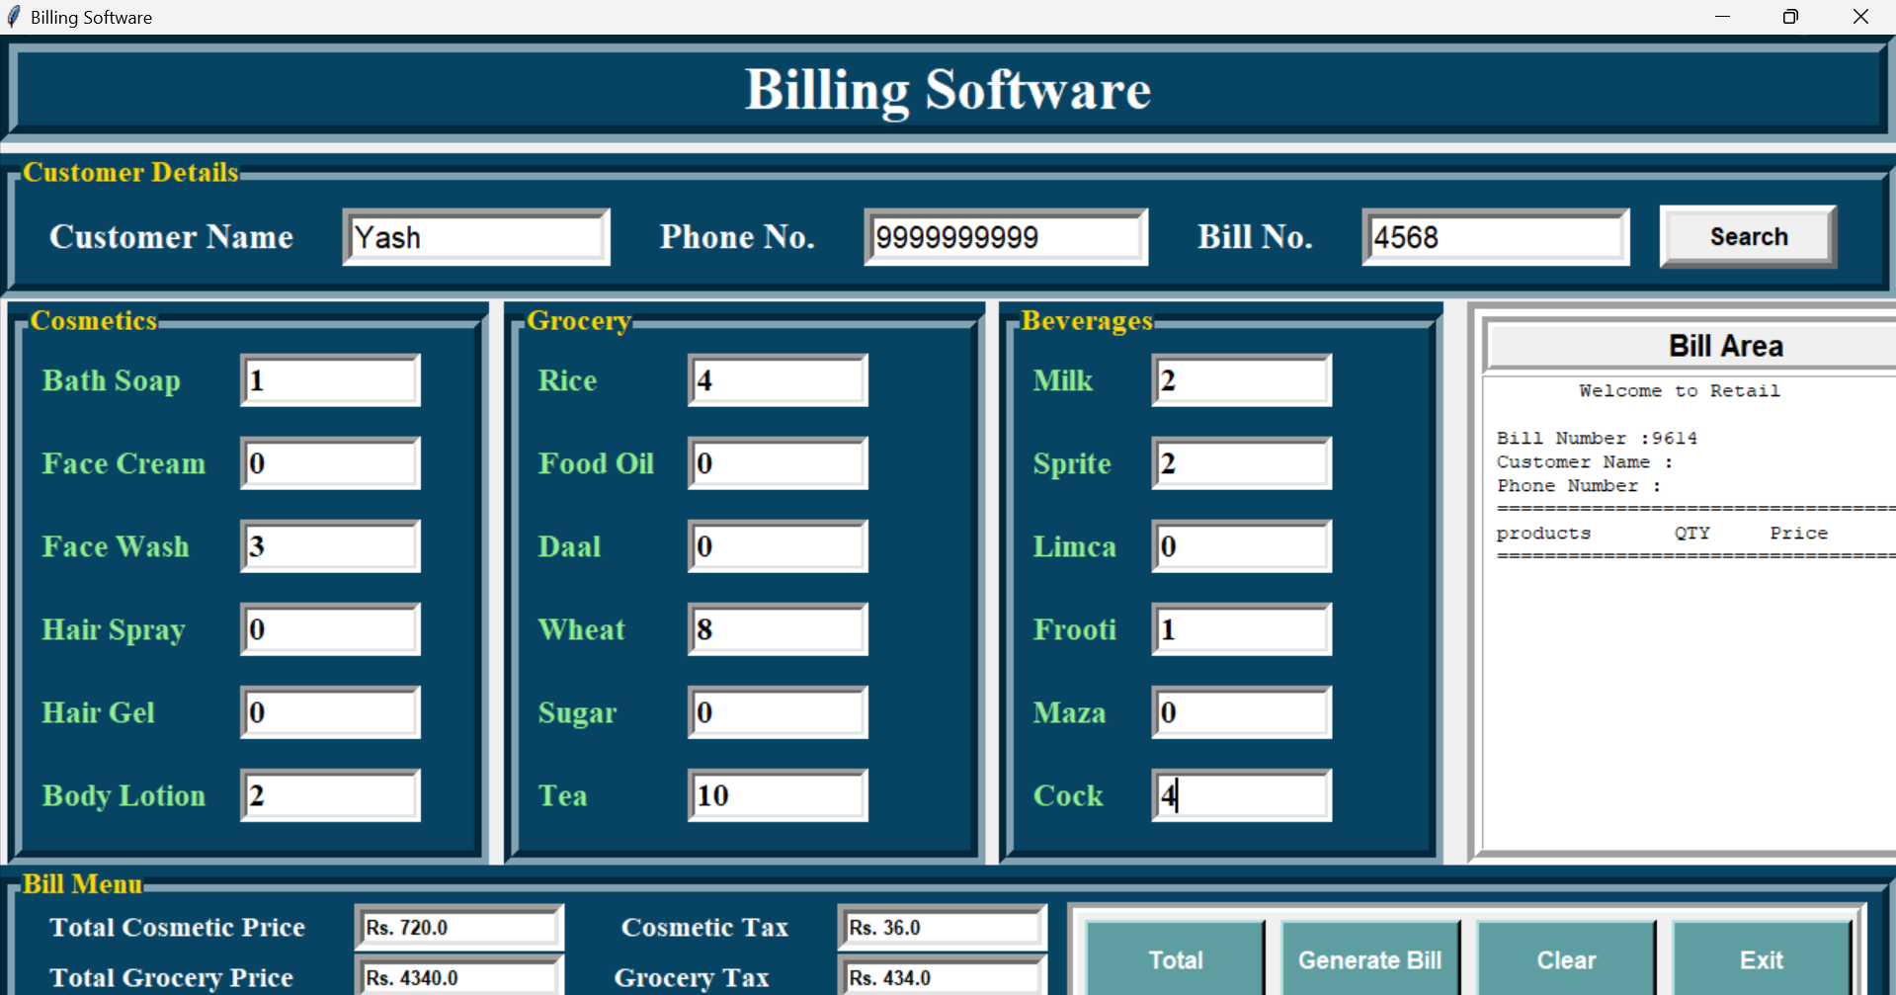

* Bill Generated by clicking on **Generate Bill Button**

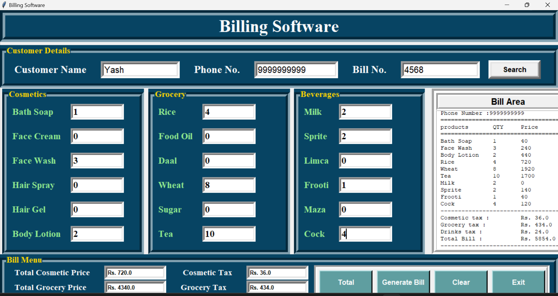

* Asking for confirmation to save the the bill locally in the computer

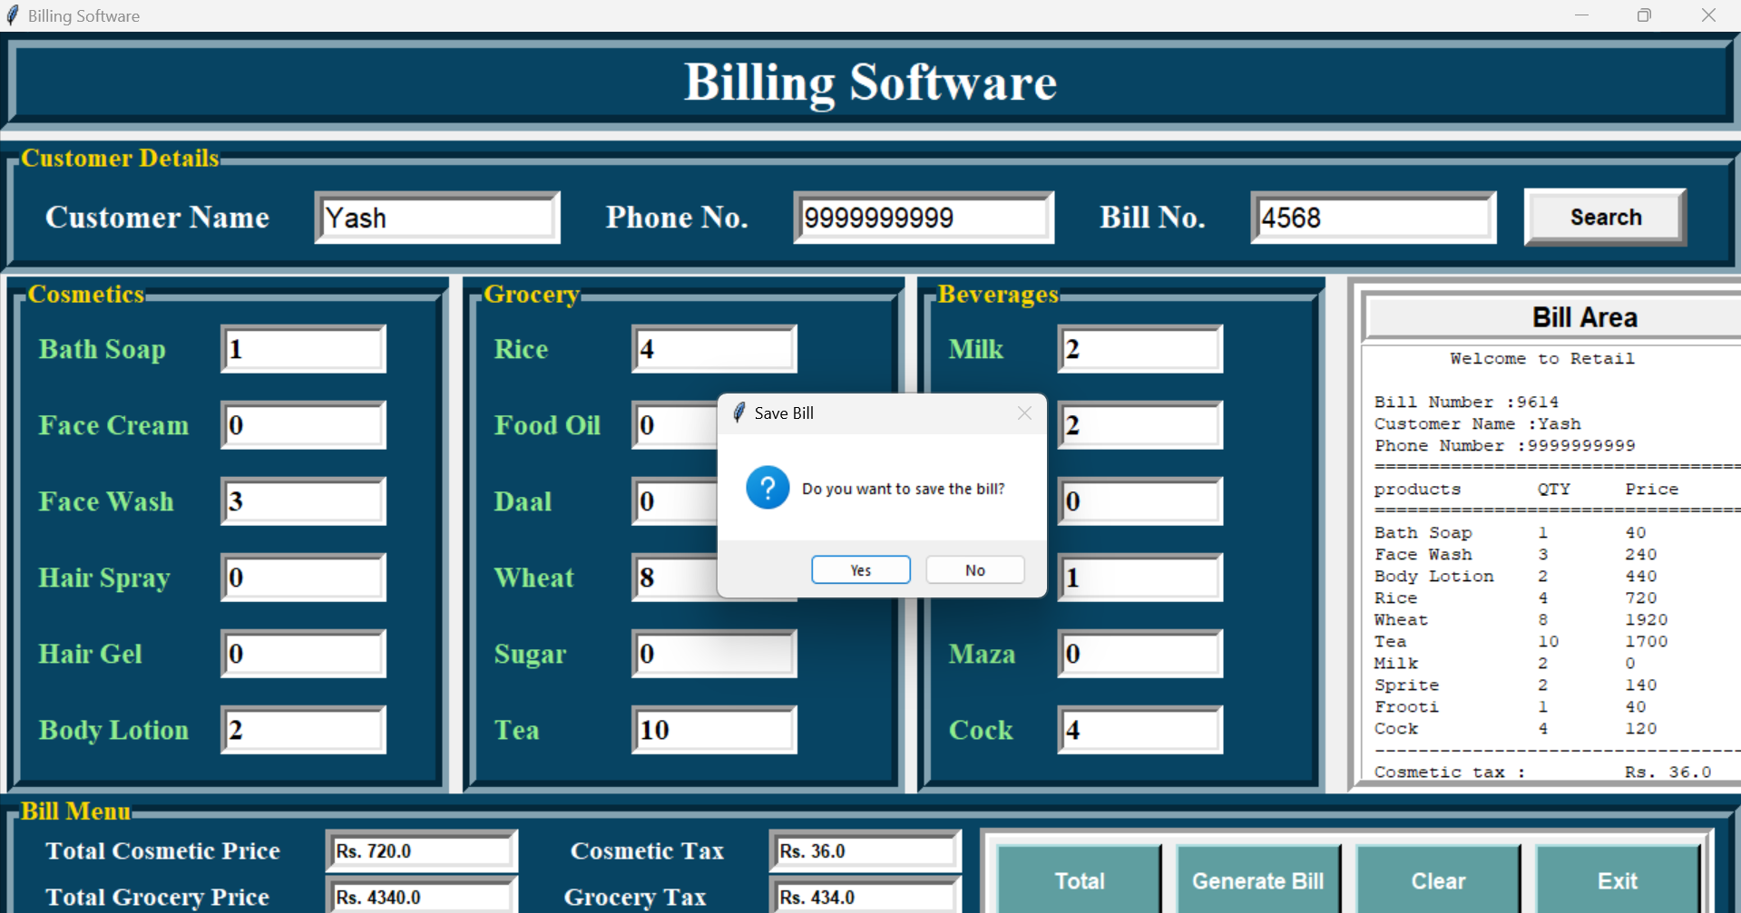

* Bill saved locally in the computer

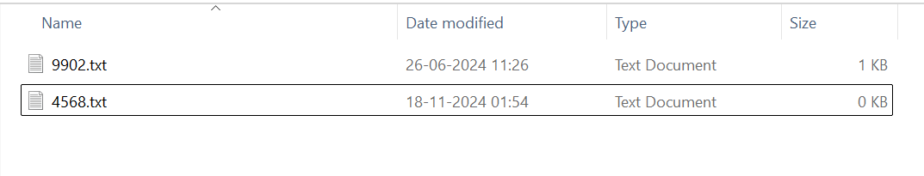

* 4568.txt

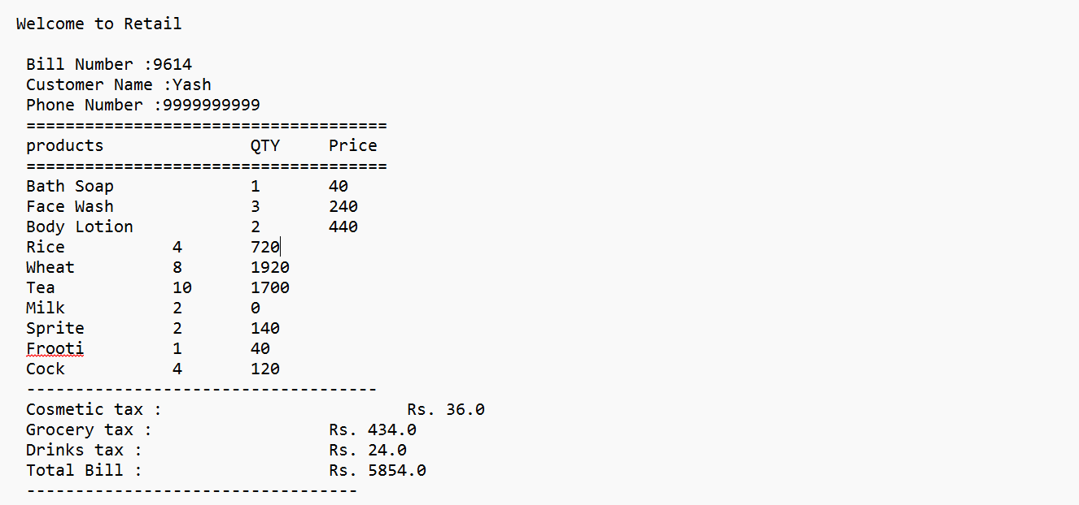

* Clearing all the input fields using **Clear Button**

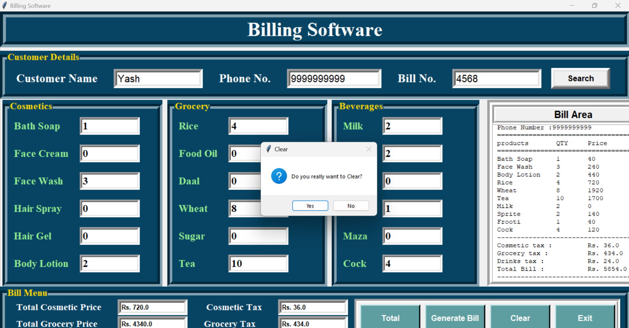

* 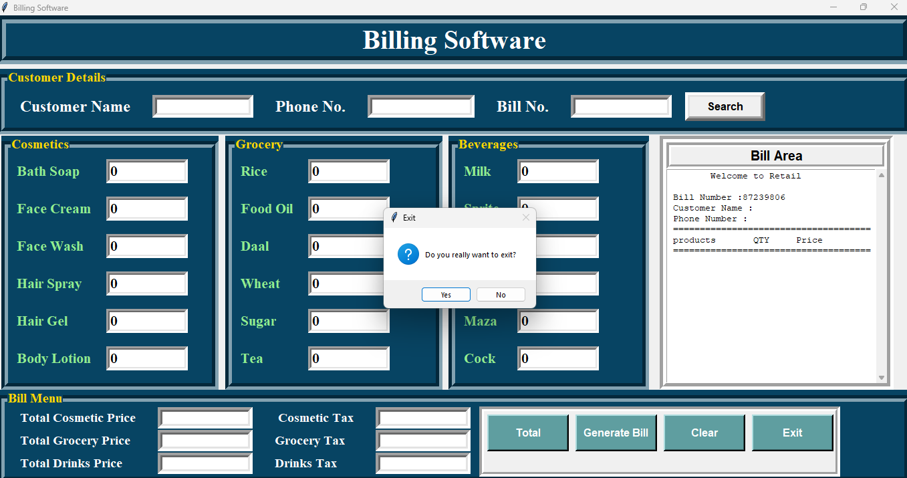Exiting the Application using **Exit Button**

**CHAPTER 5: TESTING**

**5.2 Definition and Goal of Testing**

The development of billing software involves several key phases:

1. **Problem Definition:** Identifying the specific requirements of a retail billing system.
2. **Program Planning:** Designing a robust solution that addresses user needs.
3. **Program Development:** Coding and implementing the solution.
4. **Performance Evaluation:** Testing the system to ensure it meets predefined criteria.
5. **Finalizing the Product:** Delivering a bug-free and user-friendly application.

Testing occurs during the **performance evaluation** phase to ensure that the software performs as expected, delivering accurate results for various inputs and scenarios. The main objectives of testing are:

* To evaluate system performance under real-world conditions.
* To identify and correct errors when the program is executed across various input sets and operational environments.
* To systematically detect and address errors to improve software quality with minimal effort and time investment.

Testing thus serves to validate the software’s functionality, identify edge cases, and improve overall reliability.

**5.3 Method of Testing**

Four primary testing methodologies were employed to evaluate the billing software:

1. **Unit Testing**
   * Focuses on testing individual components of the program, such as item price calculations, tax computations, and bill formatting.
   * Verifies that specific logic units function correctly and edge cases (e.g., negative inputs, zero quantities) are handled effectively.
2. **Feature Testing**
   * Assesses whether core features, such as customer detail input, product selection, and bill saving, operate as intended.
   * Each feature was tested in isolation to ensure proper functionality.
3. **Integration Testing**
   * Evaluates the seamless interaction between different components, including user inputs, backend calculations, and GUI displays.
   * Ensures that new code additions do not disrupt existing functionality.
4. **Performance Testing**
   * Measures system performance under heavy loads, such as generating multiple bills consecutively or handling extensive product lists.
   * Confirms that the system maintains stability and accuracy without crashing.

**CHAPTER 6: RESULTS**

**6.1 Test Cases and Scenarios**

1. **Edge Case Testing:**
   * Input invalid customer names and numbers (e.g., numeric names, special characters) to check error prompts.
   * Enter zero or negative product quantities to ensure validation.
2. **Functional Testing:**
   * Input multiple products across categories and verify accurate price and tax calculations.
   * Generate and save a bill, then retrieve it using the unique bill number to validate storage and retrieval functionality.
3. **Stress Testing:**
   * Generate bills with extensive item lists to evaluate system performance under load.
   * Perform consecutive transactions to test system responsiveness.
4. **User Interface Testing:**
   * Interact with every button (e.g., **Total**, **Clear**, **Generate Bill**, **Exit**) to confirm proper operation.
   * Refresh the application window to verify data persistence and GUI stability.

**6.2 Results Achieved**

* **Transaction Accuracy:** All test cases returned correct totals, taxes, and grand totals for various inputs.
* **Error Handling:** The software successfully identified and handled invalid inputs with appropriate error messages.
* **Data Storage and Retrieval:** Bills were saved and retrieved accurately, ensuring robust record management.
* **Performance Under Load:** The application handled multiple transactions efficiently without performance degradation.
* **User Experience:** The intuitive GUI passed all functional and stress tests, offering seamless operation.

**6.3 Insights from Testing**

* **System Robustness:** The application demonstrated resilience across diverse scenarios and inputs.
* **User-Friendly Design:** The interface ensured minimal learning curve and efficient operations for users.
* **Scalability Potential:** Stress tests confirmed the software’s ability to handle increased workloads with minor adjustments.

**CHAPTER 7: CONCLUSION AND FUTURE SCOPE**

**7.1 Conclusion**

This project aimed to design and implement a comprehensive billing software that simplifies retail transactions, ensures accuracy in financial calculations, and provides a user-friendly interface for seamless operations. The application was developed using Python's Tkinter library, featuring functionalities such as dynamic bill generation, tax calculation, and local data storage.

Through rigorous testing, we validated the software's performance across diverse scenarios, including edge cases and high-load conditions. Key achievements include:

* Accurate and efficient handling of categorized billing (Cosmetics, Groceries, Beverages).
* Intuitive GUI, minimizing the learning curve for users.
* Robust error handling, ensuring smooth operations even with invalid inputs.

This billing software lays a strong foundation for streamlining retail operations and is adaptable for further enhancements to cater to a wider audience. Its ability to handle multiple transactions with precision ensures it meets the demands of modern retail environments.

**7.2 Future Scope**

1. **Enhancing Features and Functionality:**
   * Introduce more product categories and customization options for businesses of varying sizes.
   * Enable discounts, promotional offers, or loyalty points integration for customer retention.
2. **Scalability for Larger Operations:**
   * Transition to a database-backed architecture for handling large-scale data storage and retrieval.
   * Optimize code for improved performance with higher transaction volumes.
3. **Cloud Integration:**
   * Incorporate cloud storage to enable centralized data management and access across multiple devices.
   * Allow remote monitoring of sales and inventory for business owners.
4. **Mobile Application Development:**
   * Develop a mobile version of the application to support on-the-go billing for small retailers or pop-up shops.
   * Include mobile payment gateways for seamless transactions.
5. **Advanced Analytics:**
   * Integrate analytics tools to provide insights into sales trends, popular products, and customer behavior.
   * Generate detailed reports for inventory management and strategic decision-making.
6. **Multi-Language Support:**
   * Add language options to cater to users from diverse regions, increasing accessibility.
7. **Web Application Development:**
   * Develop a web-based version of the software, allowing users to access and operate the system via a browser.
   * Ensure cross-platform compatibility to accommodate a broader user base.
8. **Integration with Existing Systems:**
   * Connect with existing inventory management or accounting software for holistic business management.
   * Enable integration with e-commerce platforms to unify online and offline sales data.

**REFERENCES**

1. "Programming Python" by Mark Lutz (2010).
2. "Tkinter GUI Application Development Cookbook" by Alejandro Rodas de Paz and Ashley Boucher (2018).
3. "Python GUI Programming with Tkinter" by Alan D. Moore (2018).
4. "Learning Python: Powerful Object-Oriented Programming" by Mark Lutz (2013).
5. "Object-Oriented Programming in Python" by Michael H. Goldwasser and David Letscher (2008).
6. "Software Engineering: A Practitioner's Approach" by Roger S. Pressman (2014).
7. "The Pragmatic Programmer" by Andrew Hunt and David Thomas (1999).
8. "Data Structures and Algorithms in Python" by Michael T. Goodrich, Roberto Tamassia, and Michael H. Goldwasser (2013).
9. "Clean Code: A Handbook of Agile Software Craftsmanship" by Robert C. Martin (2008).
10. Official Python Documentation - <https://docs.python.org/3/>.
11. Tkinter Documentation - <https://tkdocs.com/>.
12. Stack Overflow - Python and Tkinter Discussions <https://stackoverflow.com/>.
13. "Testing Python: Applying Unit Testing, TDD, BDD and Acceptance Testing" by David Sale (2014).